

Operational Procedure

Obtaining a NetApp Core file and Uploading to NetApp

Synopsis: This document describes the process by which a core file can be retrieved from a NetApp controller and then uploaded to the NetApp support site.

Segment: Infrastructure as a Service – Storage

Authors: Ian Daniel

Contributors:

Document Version: V1.0
Date: 27th July 2011
Document Status: Issued

CONFIDENTIAL INFORMATION
This document contains information proprietary to Thomson Reuters and may not be reproduced, disclosed or used in whole or part without express permission of Thomson Reuters.

© Thomson Reuters 2011
Contents
1 Introduction 3
1.1 Management Summary 3
1.2 Document Scope 3
1.3 Assumptions 3
1.4 References 3
1.5 Change History 3
1.6 Distribution List 3
1.7 Glossary 3
2 Procedures 4
2.1 Downloading a Core File to Your Machine 4
2.2 Uploading a Core File to NetApp 6
2.2.1 Upload the core file using https or ftp 6
2.2.2 Connecting via ftp 7

Introduction

Management Summary
This document details the process of obtaining a core file required for analysis by NetApp support in the event of a system panic. Uploading the core file to NetApp is also detailed within this procedure.

Document Scope
Obtaining and uploading core files for use by NetApp support. This is a interim procedure that will be superseded by the RSA project once that is completed and deployed.

Assumptions
It is assumed the person(s) using this procedure are conversant with NetApp hardware and software and have the required access to carry out the task.

References
 | Document | Version | Date | Author
1

Change History
Ver | Date | Author | Key Changes
0.1 | 25th July 2011 | Ian Daniel | Initial Version
1.0 | 27th July 2011 |  | Change to Issued

Distribution List
Name | Role
Peter O’Connor | Reviewer
Steven Harte | Reviewer

Glossary
Term | Definition
core file | A copy of the data stored in the core memory of a computer, usually used for debugging purposes.
ftp | File Transfer Protocol – Used to transfer files from system to system.
https | HTTPS. (HyperText Transport Protocol Secure) The common protocol used to access a secure Web server. When https:// is used as the prefix of a Web address

Procedures

Downloading a Core File to Your Machine
Verify that the core file is valid
Run the savecore -l (check mode) command on the storage system. If the proper panic string appears in the output, then the core-header is intact and can be read by NetApp (although it could still be incomplete). Make a note of the name as you will need it later. Note: On clustered systems check both controllers for core files.
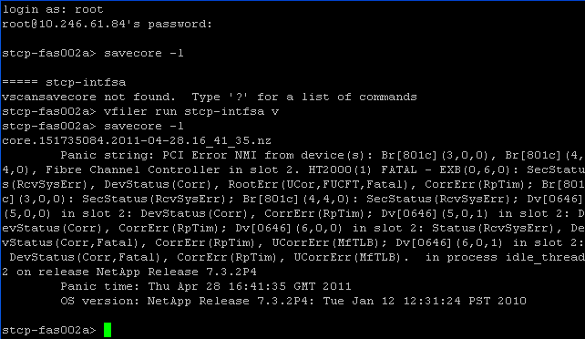
Prepare the core file for upload
On a CIFS or NFS licensed storage system, complete the following steps to prepare a core file for upload and analysis:
- If a NetApp case was not automatically created when the storage system panicked, open a case with NetApp Support by phone or web.
- Go to https://filer-ip-address/na_admin/cores/corefile_name and download the core. The corefile_name is obtained using savecore –l.

- You will be warned of a certificate error, continue past this and then authenticate when requested.
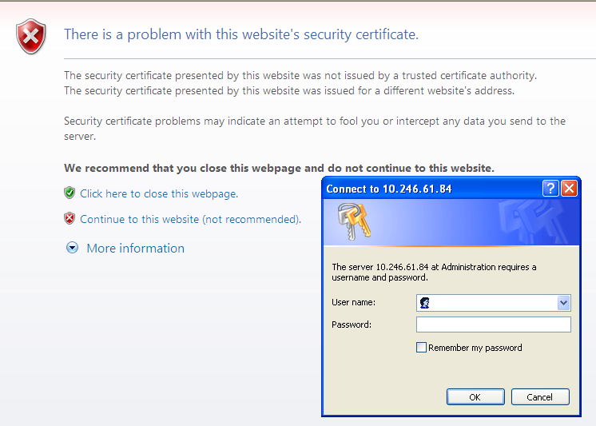
Once authenticated your download should begin. Save the file to your local machine and then move on to the upload process to get the file onto the NetApp servers.
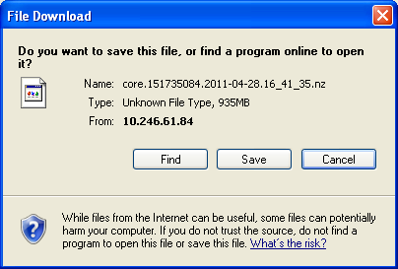
Note: You may find that transfer rates are better using http as opposed to https on certain sites. If you download using https and the estimated time is extremely long try http instead. If there is no real improvement you may be better off downloading locally and then shipping the file out from that location if possible as that will cut down on firewall traversals and WAN links. Performance will be very much dependant on network links and firewalls.

Uploading a Core File to NetApp

Upload the core file using https or ftp
Connect to the site.
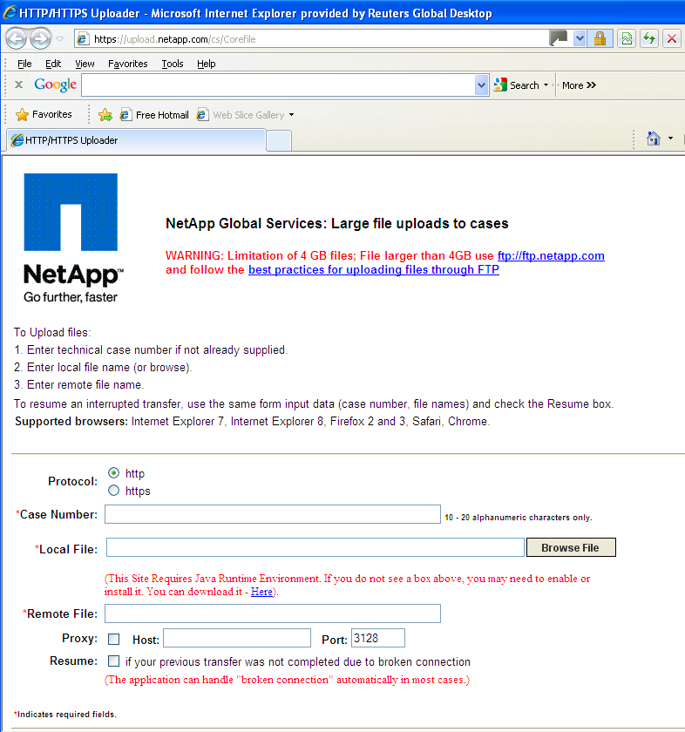
Fill in the details and transfer the file.
Note: Again, transfer rates will depend on WAN links and firewalls.

Connecting via ftp
First ensure that the core file is renamed to contain the case reference number:
For example, if the core file name is core.2.2011-03-04.08_53_25.nz and the case number is "123456", rename the core.2.2011-03-04.08_53_25.nz file to 123456.core.2.2011-03-04.08_53_25.nz.
Make sure you are doing this from the directory containing the core file. Connect to the proxy server (ftp wtd.ime.reuters.com). Once connected login using the following:
anonymous@ftp.netapp.com
For the password use your TRM email address. Once connected cd to the to-ntap directory as shown below.
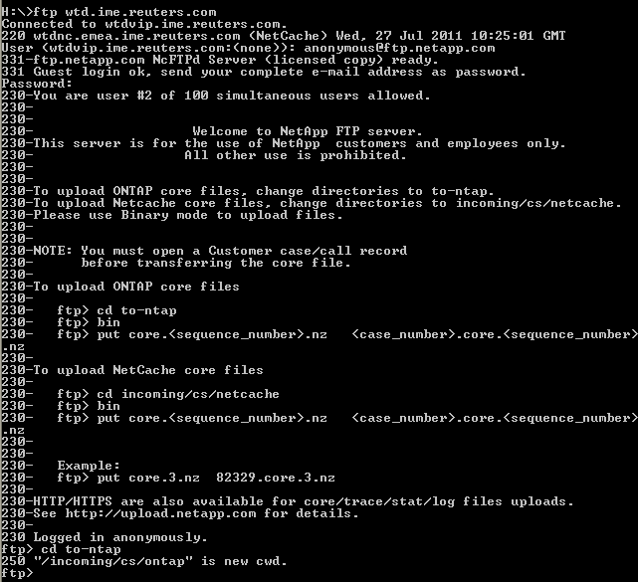
Once you are in the directory issue the following commands:
ftp> bin
ftp> hash
ftp> put corefile_name

